**WHAT ARE THE FACTORS THAT EFFECT VOLUME OF CUSTOMERS?**

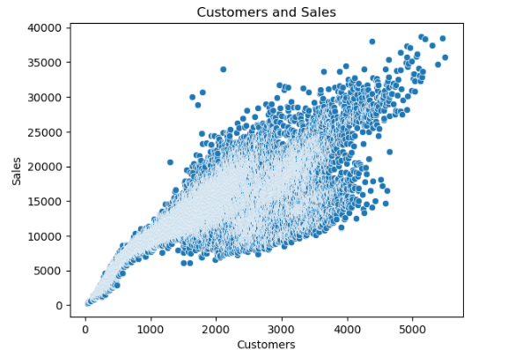From this scatterplot, it is evident that customers and sales are highly correlated, thus, more investigation into factors driving customers was performed.

Surprisingly, the side-by-side boxplots suggest that customers are not significantly influenced using promotions. This highlights the idea that the Rossman store's appeal appears to transcend the immediate need for medication, as customers frequent the store even when not personally afflicted.

For effect of competitors, the graph's negative skewness implies that stores situated closer together tend to attract a higher volume of customers. This correlation indicates that the stores in closer proximity are typically located in densely populated areas. Thus, even with competition nearby, these stores maintain a steady stream of sales due to the high local demand.

This contradicts the initial hypothesis that reduced competition would correspond to increased store traffic. It suggests that other variables play a crucial role.

**WHAT EFFECT DO COMPETITORS HAVE ON PROFITABILITY?**

Considering the impact of competitors on profitability, the histogram plotting customer footfall against sales accentuates the significance of this relationship. Further analysis revealed that stores facing new competitors between 2012 and 2014 recorded the highest sales figures.

To delve deeper, I constructed a time series graph specifically focusing on stores with competitors that emerged in 2014. The comparative analysis of sales before and after 2014 highlights a considerable decline post-2014, particularly noticeable during December, a trend likely influenced by the winter season.

The density of sales data further confirms the influence of competitors, revealing a noticeable decrease in the frequency of high sales figures post-competition entry. This suggests a notable impact on the overall profitability of the stores in question.